Fractions with the Same Denominator
Subject: Mathematics Creator: Alison Kimbley
Stand: Number Grade: 4
Content (topic)

Exploring Fractions
Outcomes  N 4.6: Demonstrate an understanding of fractions less than or equal to one by using concrete and pictorial representations to:  - Name and record fractions for the parts of a whole or a set.  - Compare and order fractions.  - Model and explain that for different wholes, two identical fractions may not represent the same quantity provide examples of where fractions are used. | Indicators  N 4.6g: Explain how denominators can be used to compare two unit fractions with numerator 1.  N 4.6h: Order a set of fractions that have the same numerator and explain the ordering.  N 4.6i: Order a set of fractions that have the same denominator and explain the ordering.  N 4.6j: Identify which of the benchmarks is closer to a given fraction.  N 4.6k: Name fractions between two benchmarks on a number line.  N4.6l: Order a set of fractions by placing them on a number line with given benchmarks.
Mathematical Processes:
- Connections
- Communication
- Problem Solving
- Reasoning
- Visualization
Lesson Preparation
Equipment/materials:
- A printed copy of the pdf version of Appendix 1 for each student and one more for each group of four students
- A printed copy of the pdf version of Appendix 2 for each group of 4 students.
Presentation
Development
- Discuss the history of the Red River cart and revisit the PowerPoint. Ask the students questions to guide their understanding of the Red River cart. Possible questions include:
  - Why was the Red River cart known for their loud squeal in their wheels? (Answer: Greasing the wheels was impractical, because the dust of the trail would cause the grease to congeal and prevent the wheels from turning.)
- Give each student a copy of Appendix 1. Have each student cut out the two rectangles on this sheet and then cut along the black lines to form 20 spokes.
- Have each student place 3 spokes on one of the wheels to divide the wheel into three equal parts. Have each student shade in one of the sectors and write the fraction $13$ in the sector.
- Have each student repeat this activity with 4 spokes on a different wheel to divide the wheel into 4 equal parts, shade in one sector and write $14$ in the sector.
- Ask the students which is larger: $13$ or $14$
- Have the students repeat this activity 3 more times using a different number of spokes of their choice each time.
- Have the students form groups of four to compare their fractions. As a group, the students should order this set of fractions and explain their system of ordering.
- After the students have found their own system, hand out the number lines and a number of small pieces of paper approximately 2 cm by 3 cm. Ask students to write their fractions on the pieces of paper and place them in order on the number line. Ask the students which of their fractions are closest to 0, 1, and $12$.
- Next, ask each group to take either seven or eight spokes and place them on one of the wheels on a fresh copy of Appendix 1. Shade in some of the sectors and write the fraction that represents the proportion of the wheel that is shaded. Move to another wheel and repeat the process with the same number of spokes but shading a different number of sectors. Repeat for the remaining three wheels to obtain five fractions with the same denominator and different numerators.
- After five different fractions are created, have the students order the set of fractions which all have the same denominator and explain the ordering.
- After the students have found their own system, hand out paper approximately 2 cm by 3 cm. Ask students to write their fractions on the pieces of paper and place them in order on the number line. Ask the students which of their fractions are closest to 0, 1, and $12$.
Appendix 1

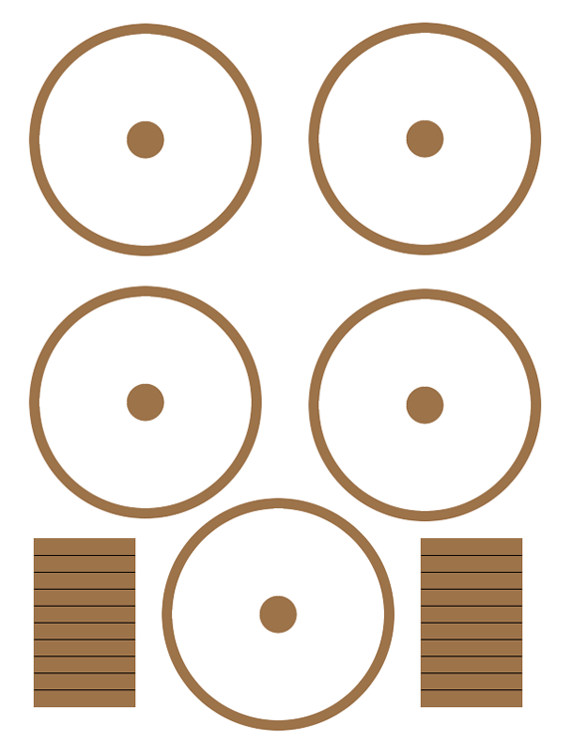

Appendix B

